**Creating Virtual Machines:**

Install VMware Hypervisor -

**-Windows server:**

-open VMware

-Create virtual machine on VMware Hypervisor

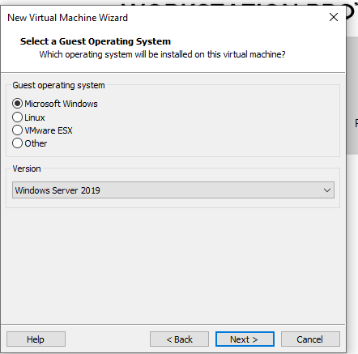

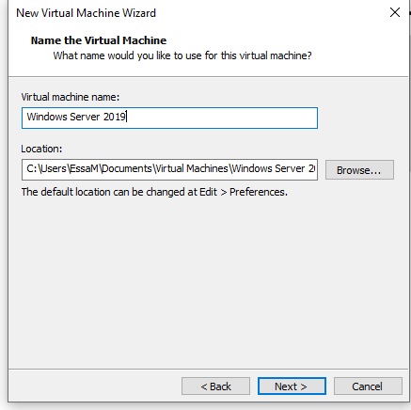

**-Download the official ISO image for:**

● Windows server: Download from the Microsoft website.

<https://www.microsoft.com/en-us/evalcenter/download-windows-server-2019>

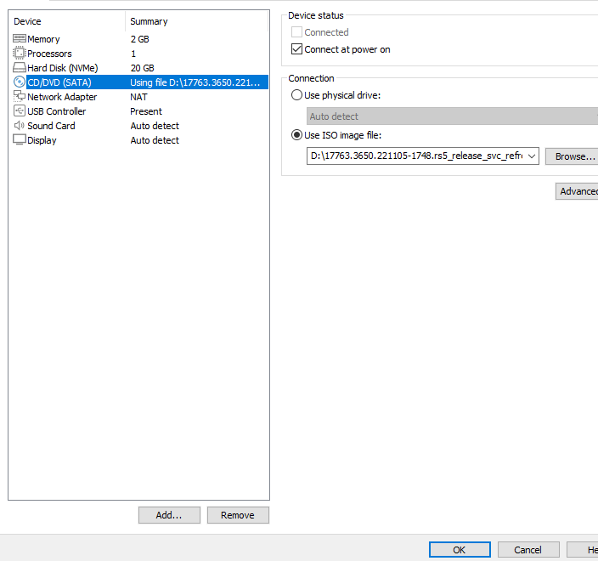

**-power on this virtual machine to setup server:**

**-Creating user, password**

**Then select ctrl+Alt+Del to unlock**

- chick right on windows server 2019 , select install VMware tools

- install VMware tools From: Start, file explorer, D:vmware tools , setup

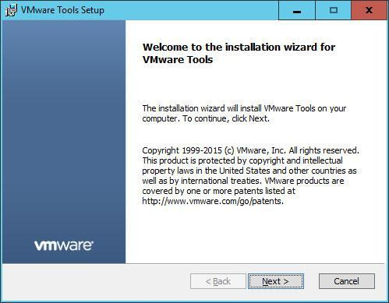

Then restart windows

**● Install IIS and web services**

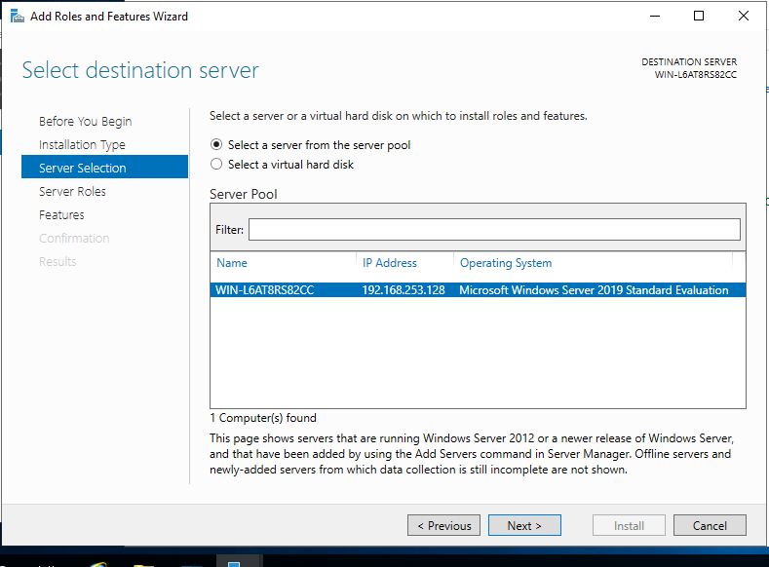

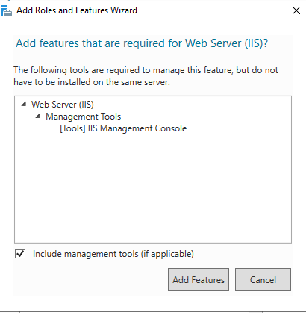

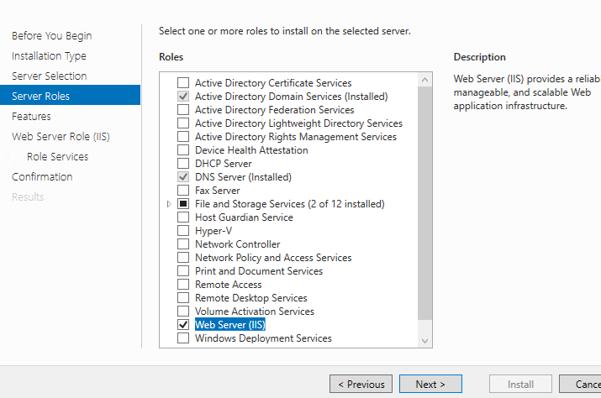

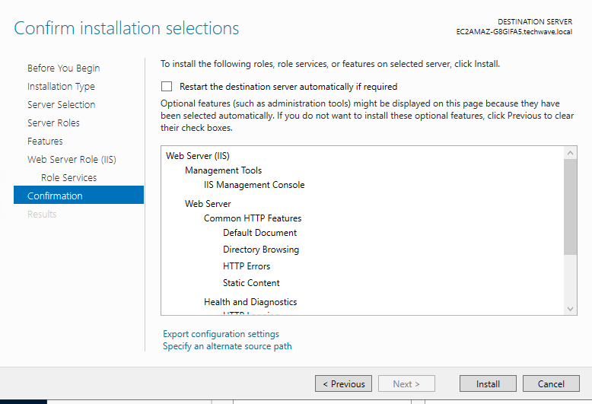

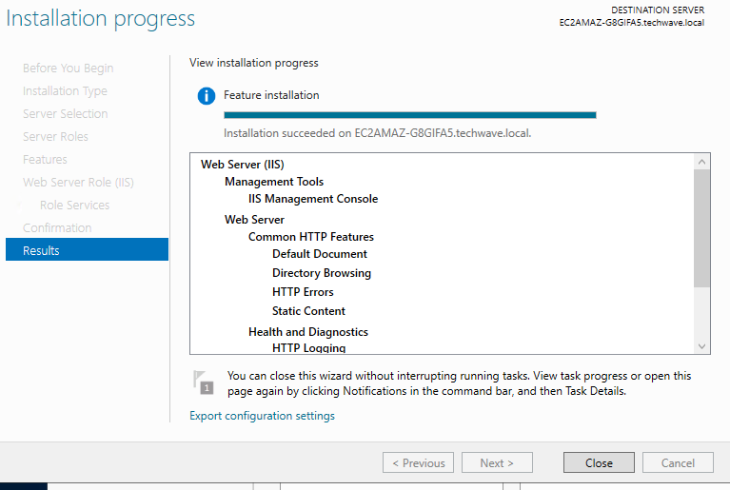

**Add website:**

Site name: techwave

Port:8080

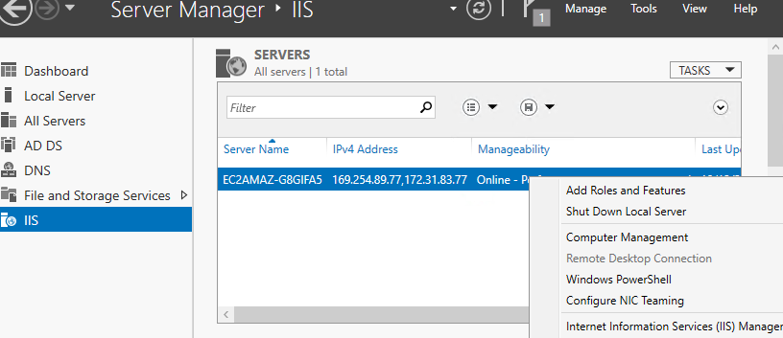

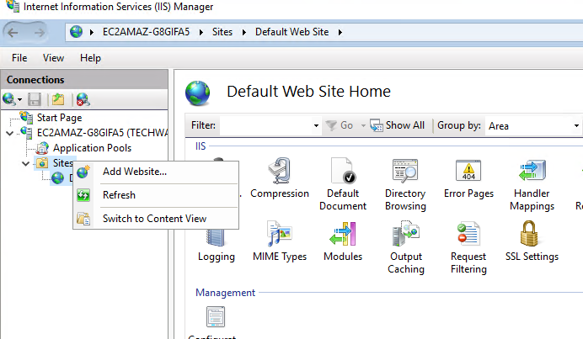

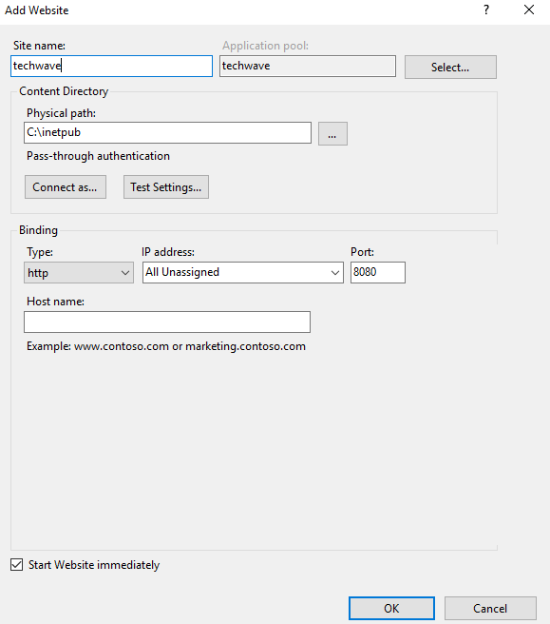

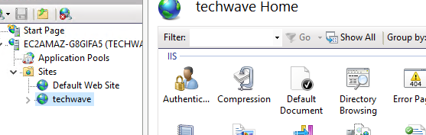

**Then open internet explorer and search about this web**

**-setup active Directory:**

- Open control panel, all control item then network and sharing center

IP Address: 172.31.83.77

IP DNS server: 172.31.83.77

**-setup active Directory, DNS:**

Add roles and features

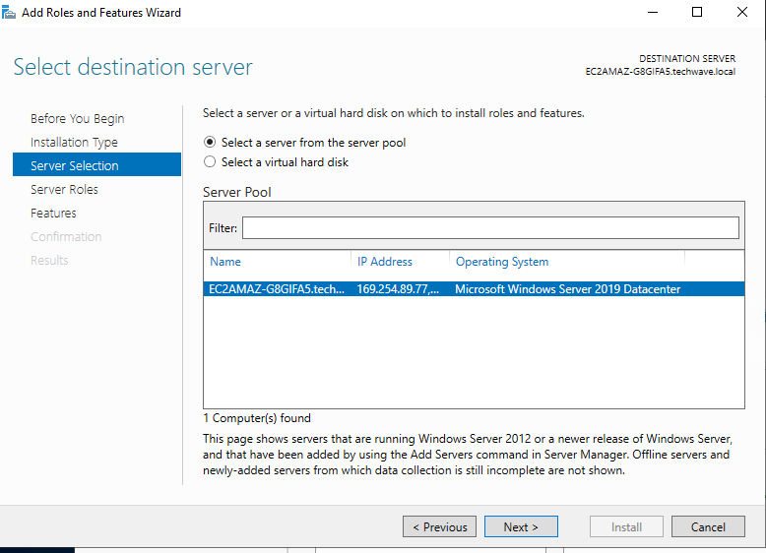

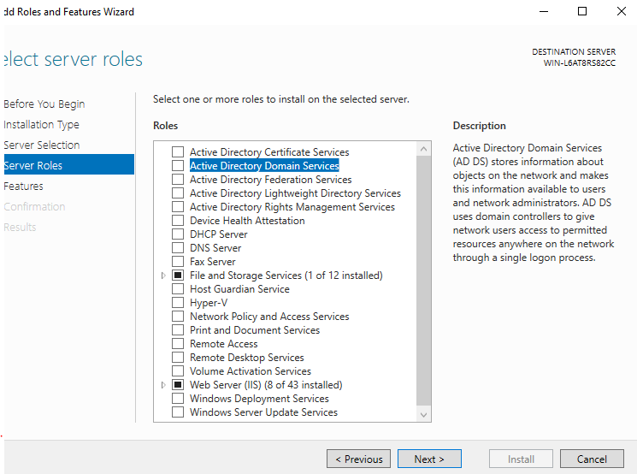

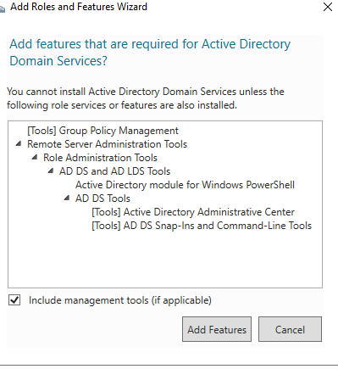

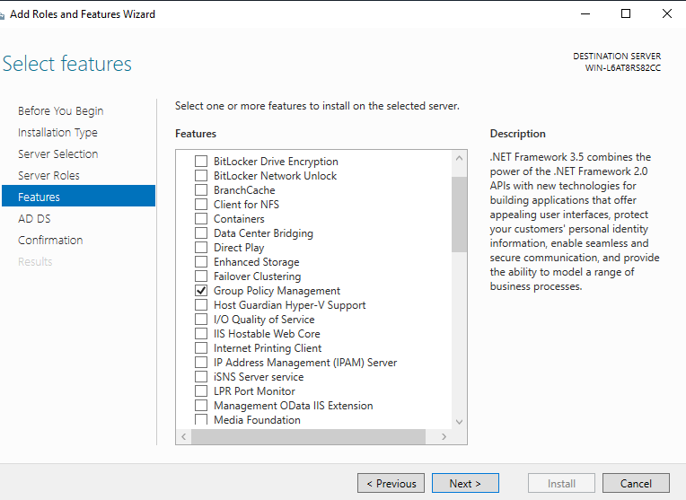

-install active Directory

-add a new forest

-then select the lowest server and domain server that can be communicated with it

-setup Dns

-create password to protect your information

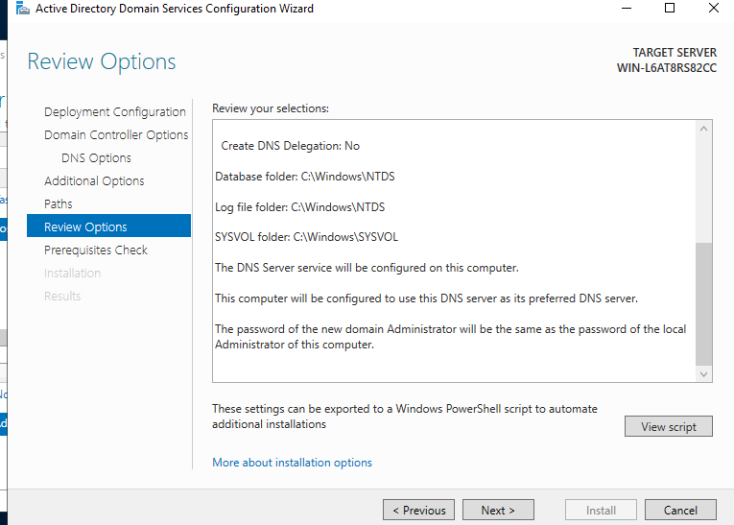

-install active directory and restart automatically

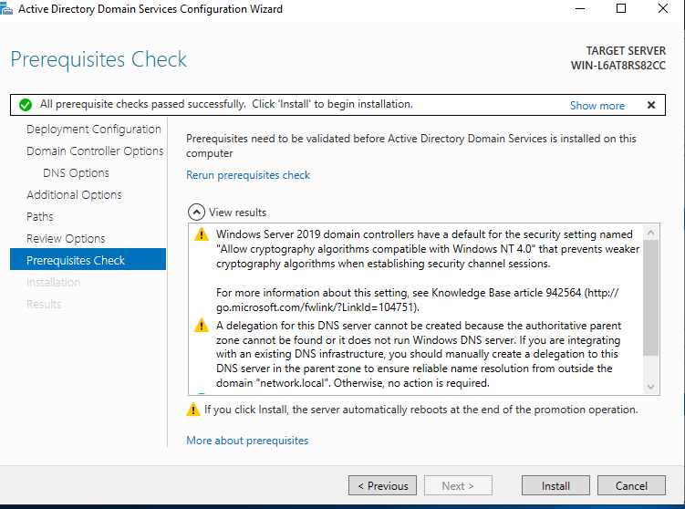

-active directory , domain and many tools of active directory (Done)

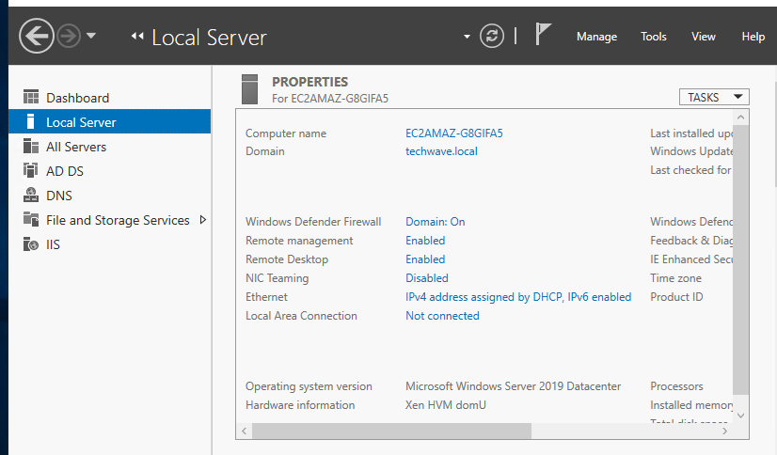

**Setup DHCP:**

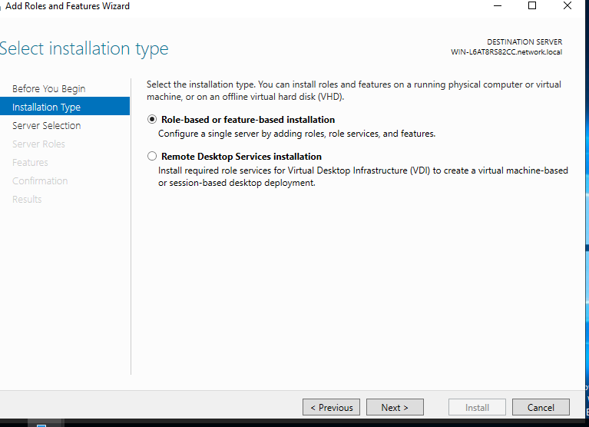

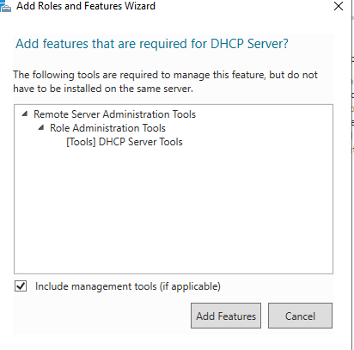

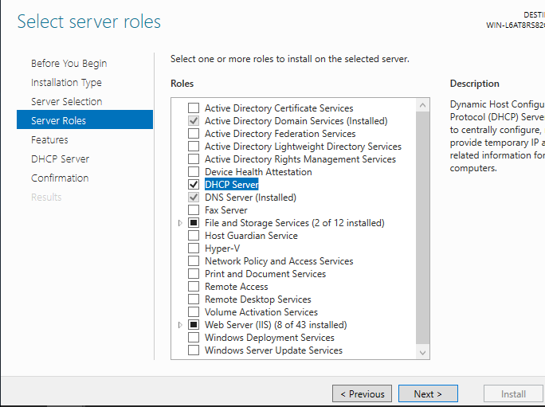

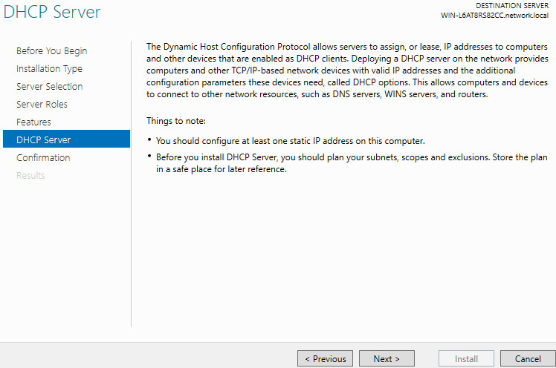

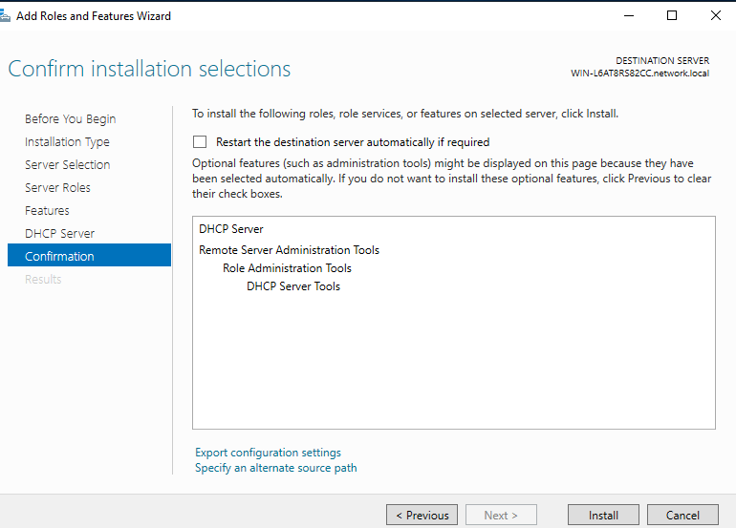

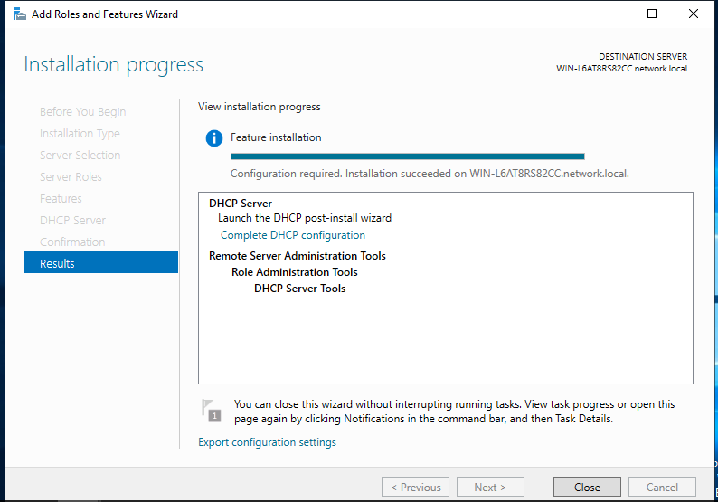

**Add users:**

Tools, Active Directory Administrative center, users, new, user

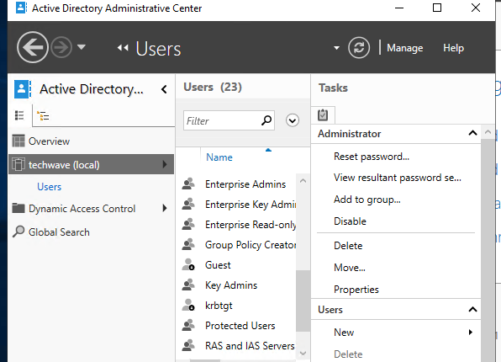

Creating user:

Full name: Esraa mubarak

User samaccount: Esraa mubarak

Select user must change passward at next log on

Then press (ok)

Then create user Abdullah fawzi at the same way.

**Creating Group:**

Select user, new, Group

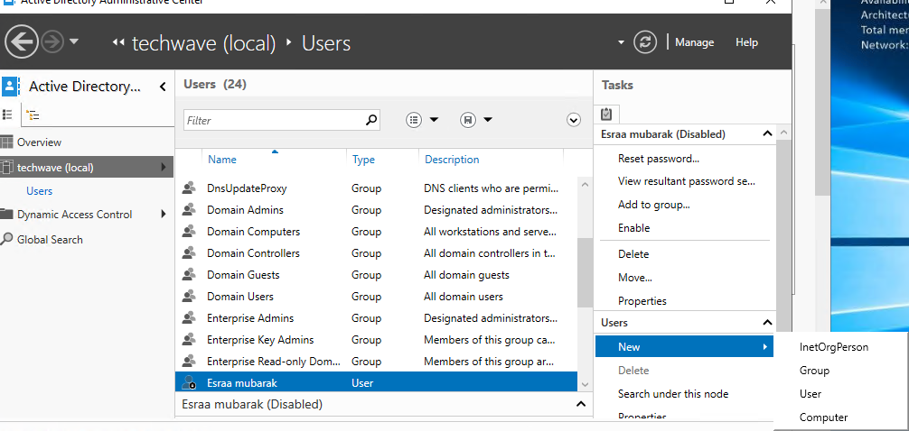

**Create Group:**

Group name and Group samaccount: IT Admin

Description: All of member of the IT Admin group

-Add member:

Add, Esraa Mubarak(user)

Then add Abdullah fawzi, Administrator at the same way

**Create OU for sales Team:**

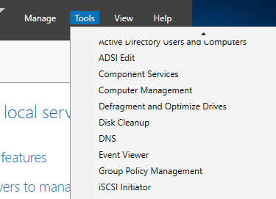

Then create OU for IT Admin, HR, Development Team at the same way

**-Create GPO for Sales Team:**

**-Create GPO for IT Admin, HR, Development Team at the same way**

**-Add computers for sales Team:**

-then add others computers that are in sales Team

**-Add computer for IT Admin, HR, Development Team at the same way**

**1-GPO for IT Admin:**

**To set the password length for IT Admin: at least 8 characters**

Edit, computer configuration, windows setting, security settings, Account policies, minimum password length

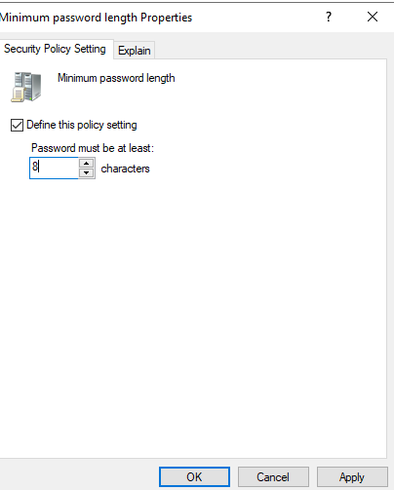

**2--GPO for sales Team:**

Control the use of external devices (USB Policy) :

Edit, computer configuration, Administrative Templates, system, Removable storage Access, Deny rwx access, enabled

**3- GPO for Development Team:**

**Data Encryption:** Enforce an encryption policy on all data stored on server used by the development team to secure sensitive data.

Edit, computer configuration, windows setting, security settings, public key policies, Encrypting file system, properties, allow to encrypt content

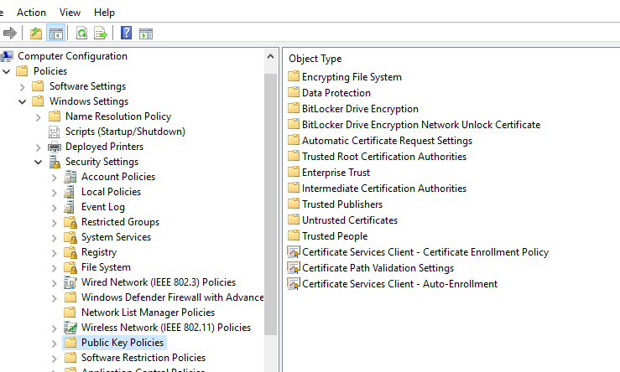

**4- GPO for HR:**

**Personal data management policies:**

Edit, computer configuration, windows setting, security settings, file system, add file, select file (employee income), add employee in HR Team (salma, sam), ok

**-printer:**

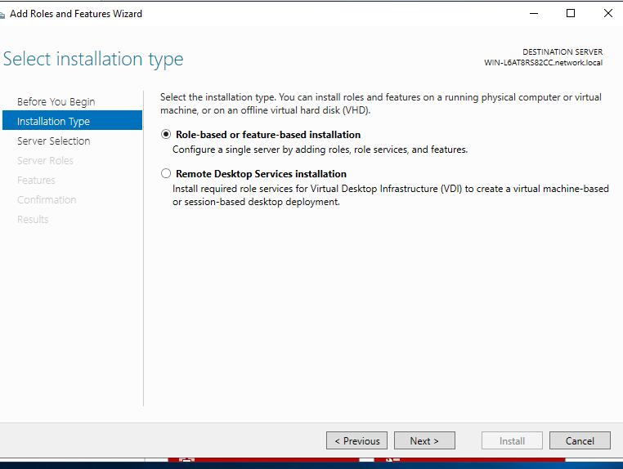 

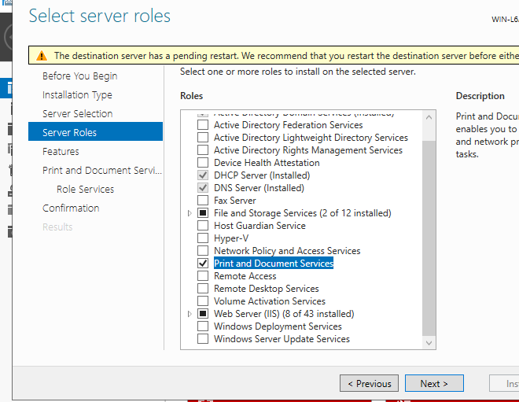

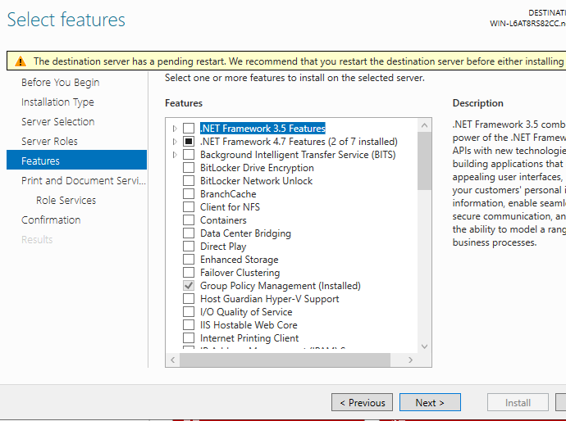

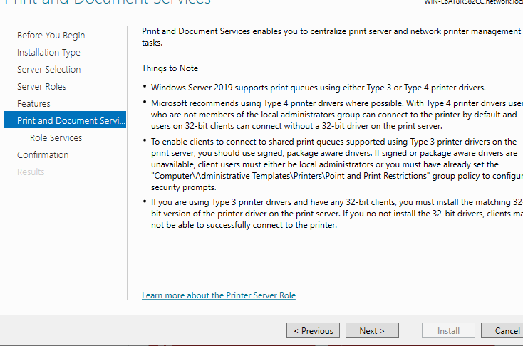

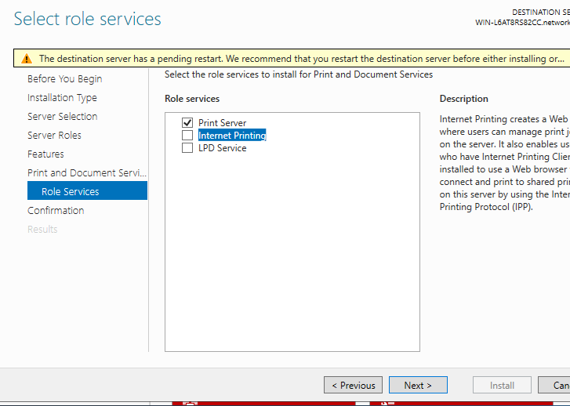

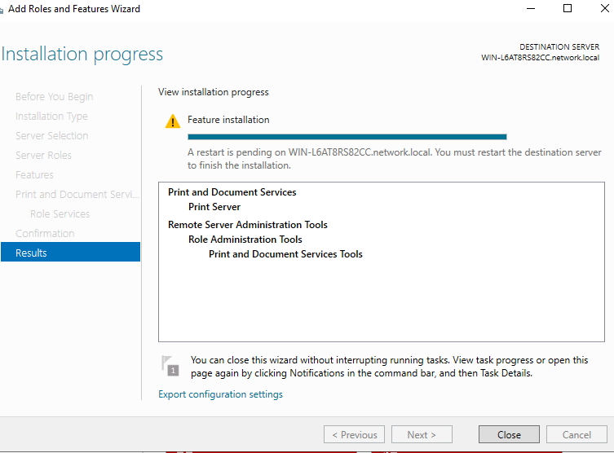

**-In addition, there is a virtual printer:**

1-microsoft PCL6 Class Driver.

2- Microsoft XPS Document writer.

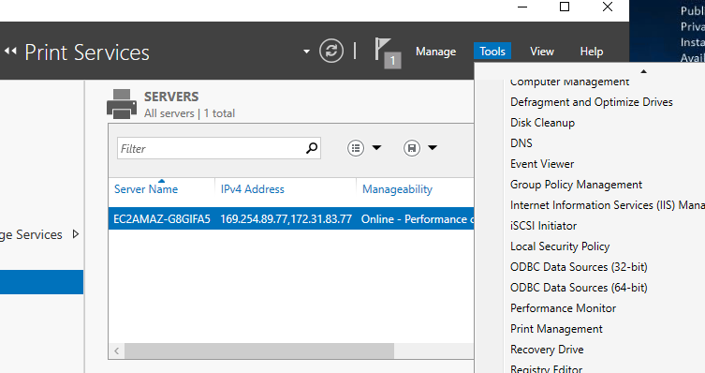

-**install Samba share**: To share files and folders

**- share folder by samba**

-click right on space, new share

**-Another way to share:**

Create folder, add data, properties,

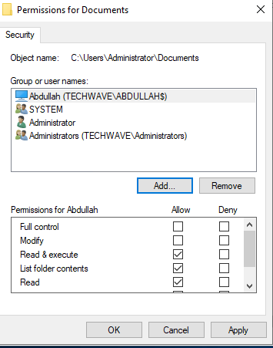

**-To activate shared folder :**

Start, computer management, shared folders, shares

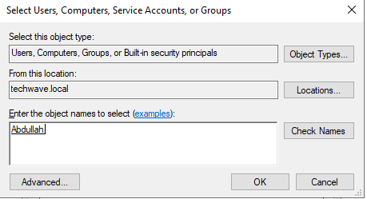

**-to ensure this files (automation, share) shared:**

Open Abdullah pc (File explorer, search about ip for this server (174.129.110.136))

**Back up:**

-sarver manger, Add roles and features, features, windows server Bckup, next, install

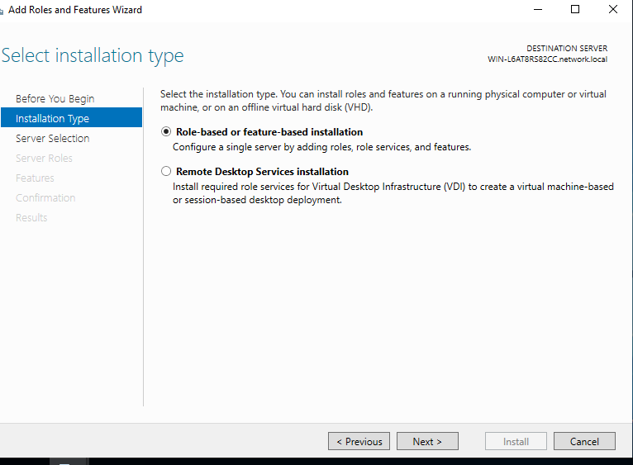

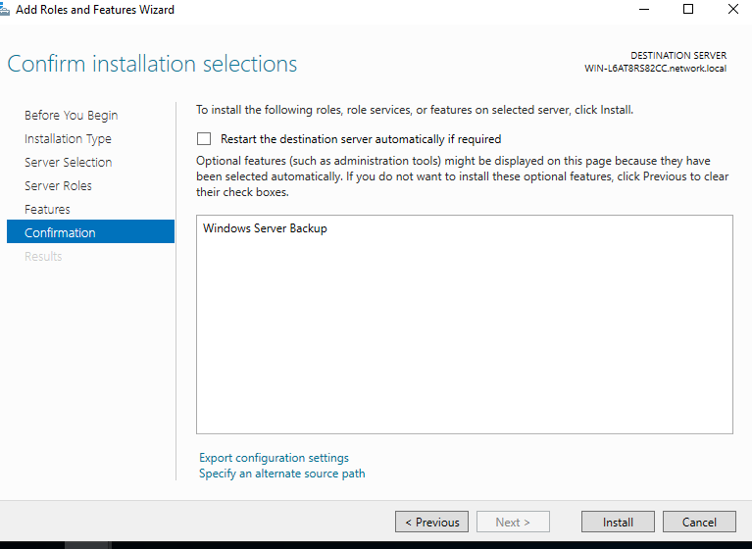

**-to create backup for custom (omnia):**

start, Windows Server Backup, Local Backup, Backup Once, Different options, custom, add items, select folder (omnia), select the location where the backup will be saved, Backup.

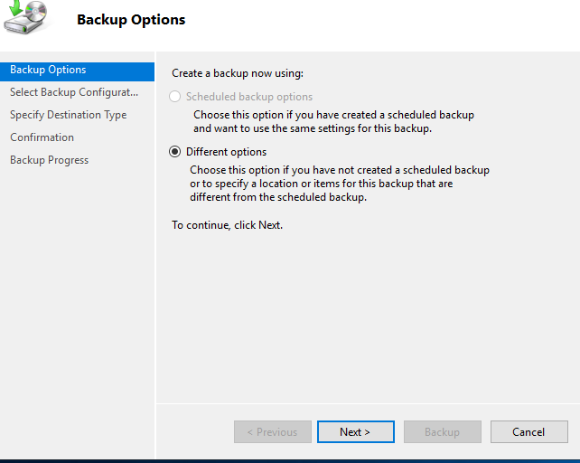

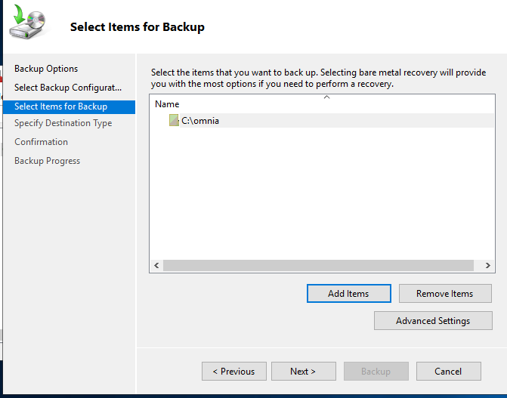

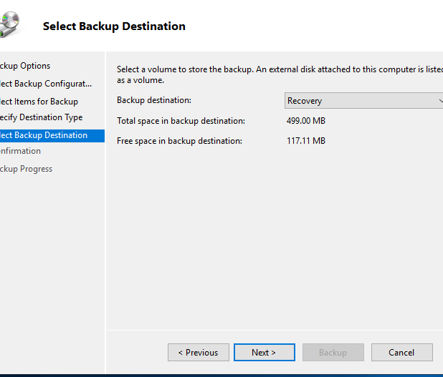

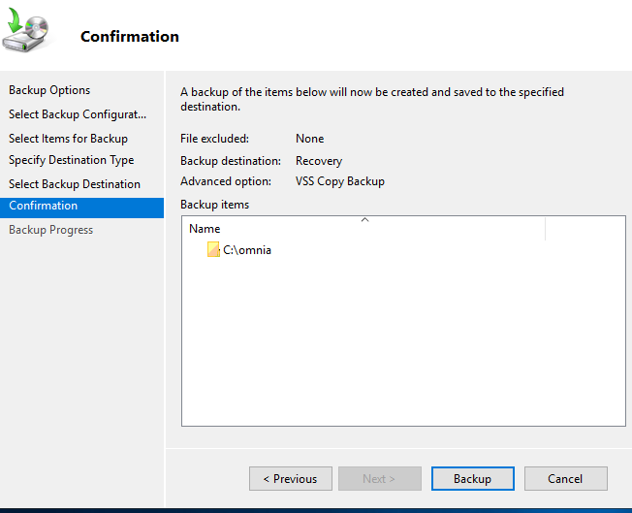

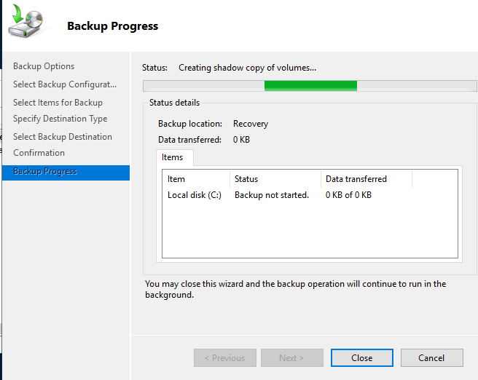

**-To ensure that backup is working:**

start, Windows Server Backup

